AGROSPHERE SPECIFICATION SHEET
Premium Nigerian Hibiscus Flowers (Hibiscus sabdariffa)
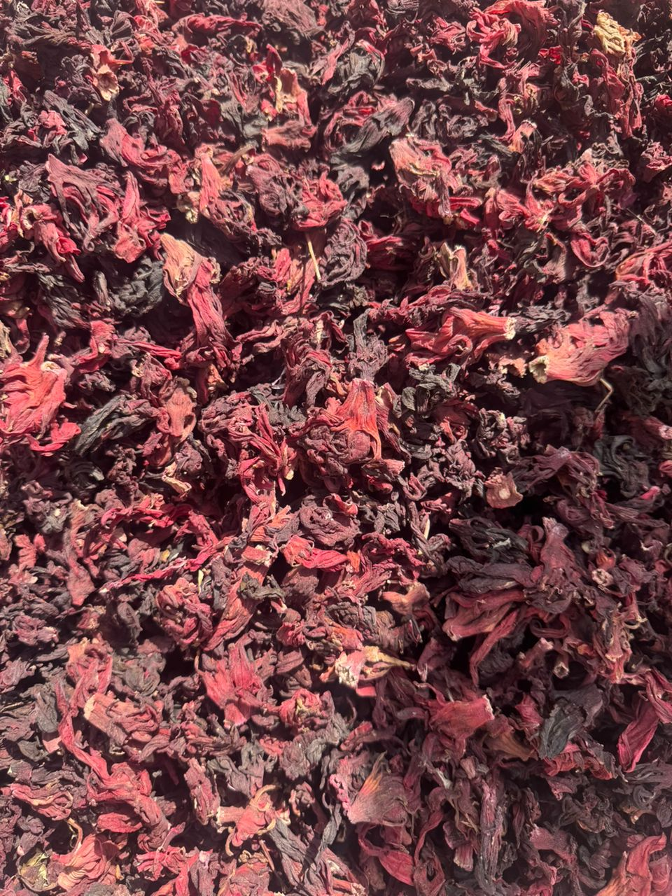
Introduction:
Sourced from the fertile plains of northern Nigeria, our hibiscus flowers are renowned for their deep red colour, rich flavour, and high purity. They are ideal for international food and beverage manufacturers.

Product Specifications Table:
Parameter | Standard Specification
Product Name | Dried Hibiscus Flowers
HS Code | 12119029
Colour | Dark Red
Moisture Content | < 12%
Purity/Impurities | < 2%
Foreign Matter | Nil
Origin | Nigeria

Packaging & Logistics
- Standard Packaging: 25kg Polypropylene (PP) bags. Custom packaging available on request.
- Loading Capacity: Approximately 12 Metric Tons in a 40ft container.
- Inspection: SGS or other third-party inspection available at buyer's request.
- Shipment: Prompt shipment from Lagos, Nigeria, to all major global ports.

(CALL TO ACTION BUTTON): Request a Quote for Hibiscus Flowers

