Specification Sheet
Product: Nigerian Natural Sesame Seeds (Sesamum indicum)
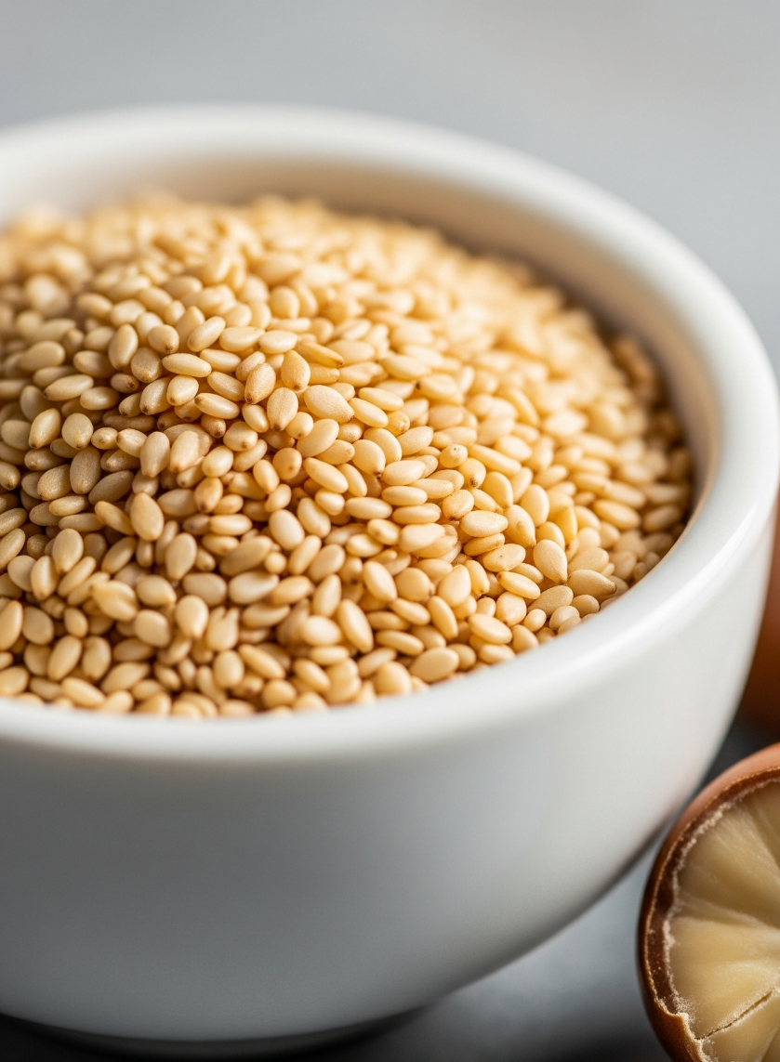

Introduction
Our sesame seeds are sourced from the best farms in Nigeria and are prized for their high oil content and nutty flavour. They are meticulously cleaned and prepared for the international market.
Product Specifications Table:
Parameter | Standard Specification
Product Name | Natural Hulled Sesame Seeds
Purity | 98 - 99.5% Min
Oil Content | 48% Min
Moisture Content | < 6%
Free Fatty Acid (FFA) | < 2%
Origin | Nigeria

Packaging & Logistics:
- Standard Packaging: 50kg Polypropylene (PP) bags.
- Loading Capacity: Approximately 19 Metric Tons in a 20ft container.
(CALL TO ACTION BUTTON): Request a Quote for Sesame Seeds

